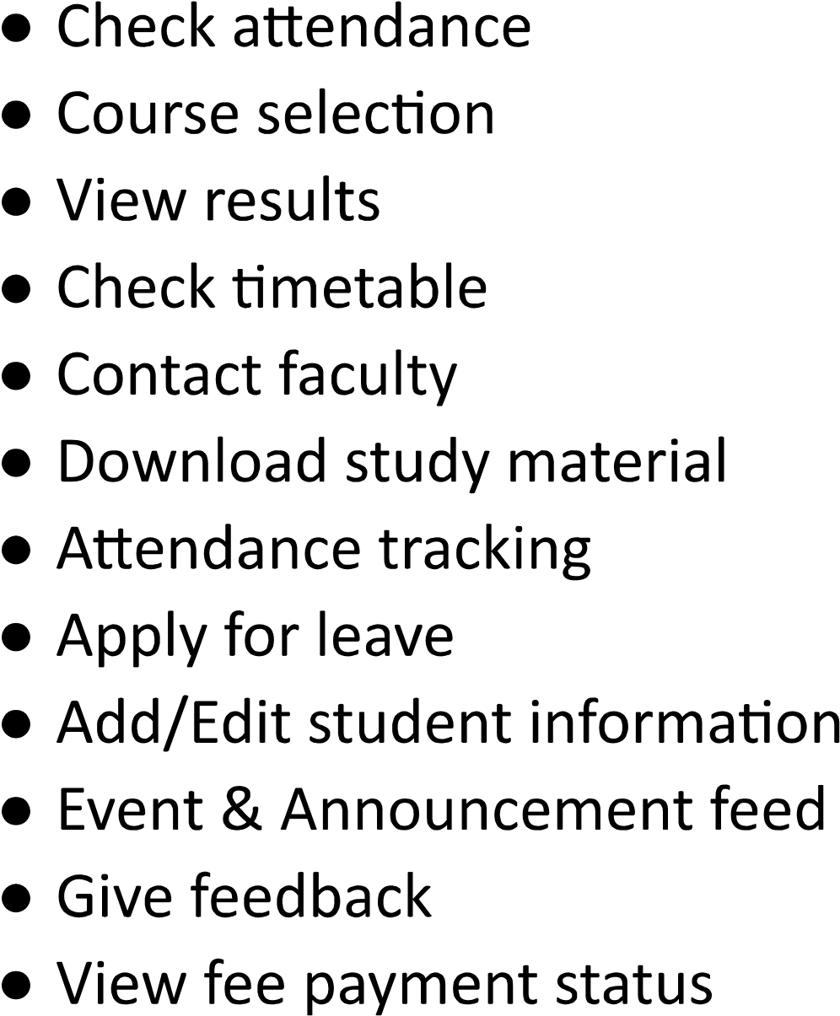

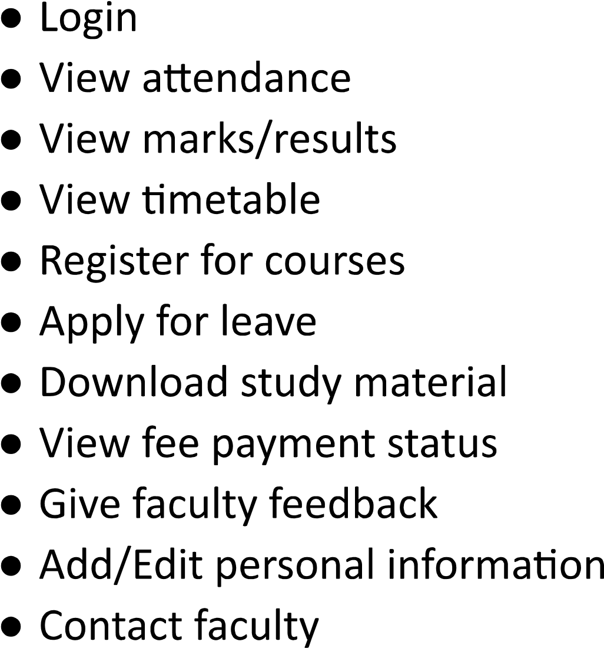

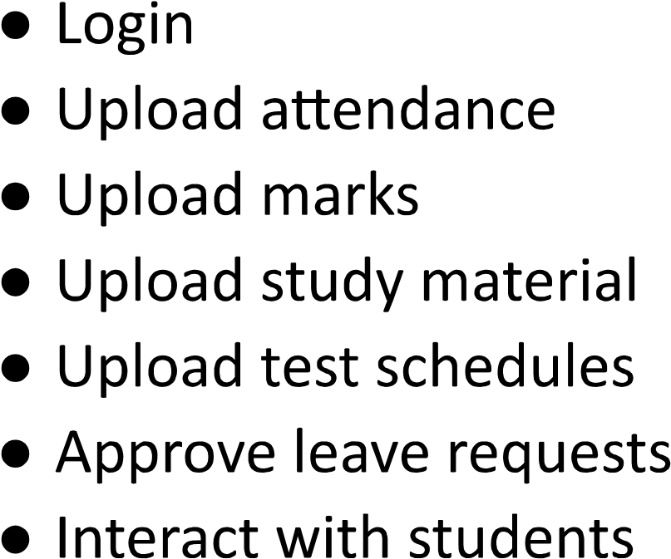

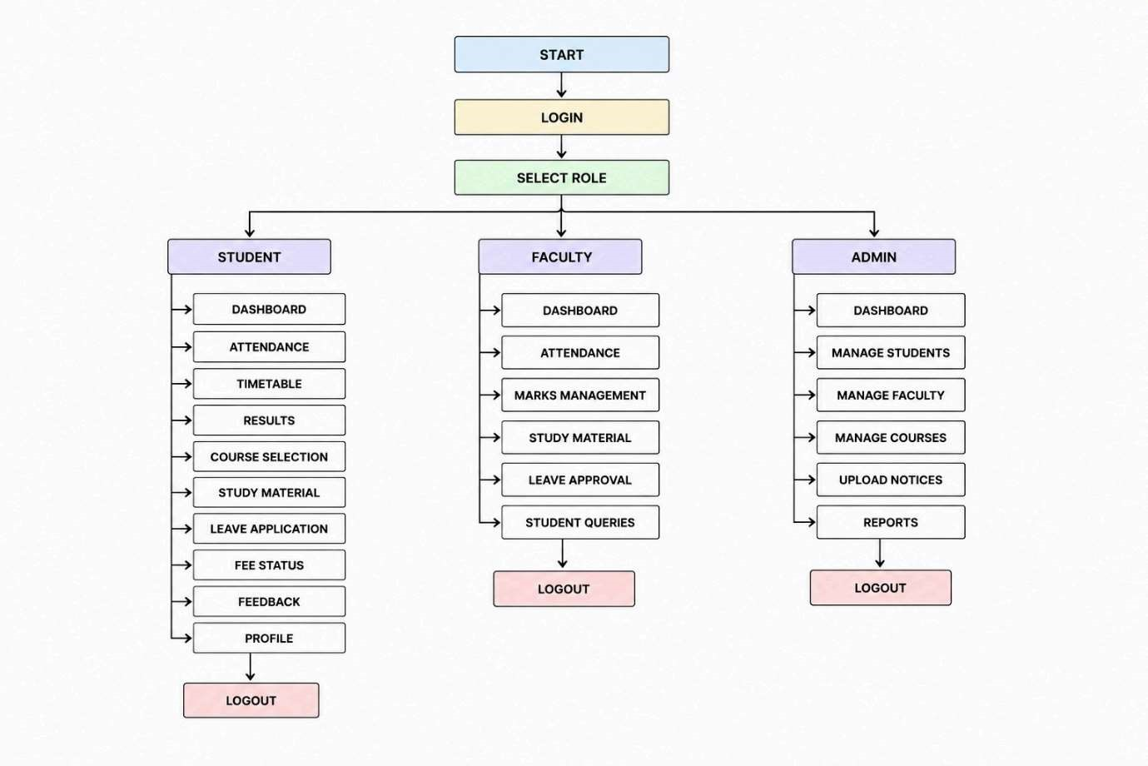
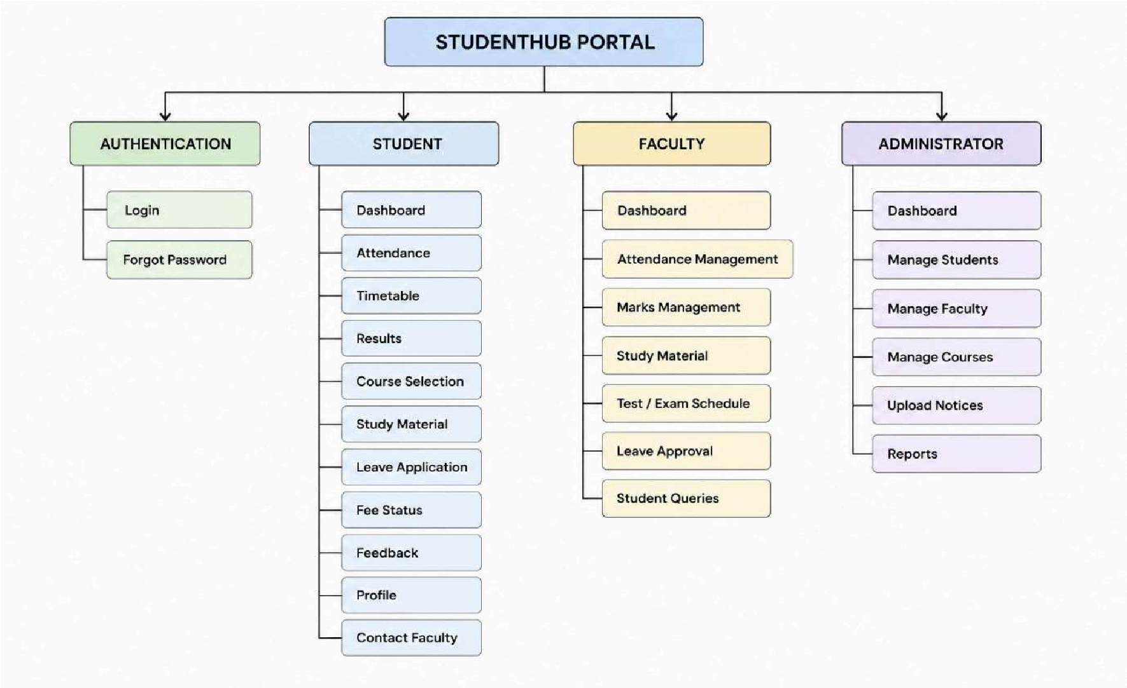

SELECT ROLE
PASSWORD
USERNAME
LOGIN

ATTENDANCE
RESULTS
FEE STATUS
MY COURSES
DASHBOARD
ANNOUNCEMENT
TODAY’S TIMETABLE

OVERALL ATTENDANCE
SUBJECT ATTENDANCE
ATTENDANCE

TIMETABLE

TIME MON TUE WED THU FRI

RESULTS

SEMESTER
SUBJECT GRADE

SGPA
CGPA

COURSE SELECTION
COURSE CODE COURSE NAME CREDITS SELECT

SUBMIT

STUDY MATERIALS

SUBJECT MATERIAL

LEAVE APPLICATION
LEAVE TYPE

START DATE
END DATE
REASON

SUBMIT

FEE STATUS

DUE
PAID
TOTAL FEES

FEEDBACK
SELECT FACULTY

YOUR FEEDBACK

PROFILE

PHOTO
NAME

ENROLLMENT NO.
EMAIL
PHONE
DEPARTMENT

CONTACT FACULTY
FACULTY NAME EMAIL

7.Project folder structure

- CSS
- Images
- js
- README

